ZTW Spider Series 40A OPTO Brushless Speed Control ECS for Multicopter Qudcopter Airplane Part

ZTW Spider Series 40A OPTO Brushless Speed Control ESC 2-6S Lipo for DJI Flame Wheel F450 F550

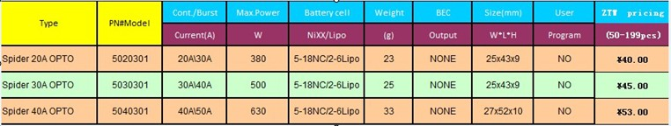

Features:

Continuous Output: 40A

Burst Output: 50A

Max. Power: 630W

Battery: 5-18NC/2-6Lip

Length: 52mm

Width: 27mm

Height: 10mm

Supports high RPM motors

Extremely low internal resistance

Super smooth and accurate throttle linearity

Safety thermal over-load protection

Auto throttle shut down in signal loss situation

Power arming protection (prevents the motor from accidentally running when switched ON)

Use new generation of the MOSFETs ensuring low heating and more reliability operation

Package Include:

1 x ZTW Spider 40A ESC